**Saqib Shehzad**

**2021-CS-187**

Week 7 + 9 tasks :

**Task 1: First Come First Serve (FCFS):**

#include<stdio.h>

int main()

{

int n,bt[20],wt[20],tat[20],avwt=0,avtat=0,i,j;

printf("Enter total number of processes(maximum 20):");

scanf("%d",&n);

printf("\nEnter Process Burst Time\n");

for(i=0;i<n;i++)

{

printf("P[%d]:",i+1);

scanf("%d",&bt[i]);

}

wt[0]=0; //waiting time for first process is 0

//calculating waiting time

for(i=1;i<n;i++)

{

wt[i]=0;

for(j=0;j<i;j++)

wt[i]+=bt[j];

}

printf("\nProcess\t\tBurst Time\tWaiting Time\tTurnaround Time");

//calculating turnaround time

for(i=0;i<n;i++)

{

tat[i]=bt[i]+wt[i];

avwt+=wt[i];

avtat+=tat[i];

printf("\nP[%d]\t\t%d\t\t%d\t\t%d",i+1,bt[i],wt[i],tat[i]);

}

avwt/=i;

avtat/=i;

printf("\n\nAverage Waiting Time:%d",avwt);

printf("\nAverage Turnaround Time:%d\n",avtat);

return 0;

}

**Output:**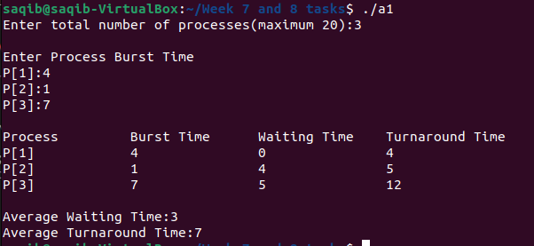

**Task 2: Priority Scheduling Algorithm:**

#include<stdio.h>

int main()

{

int bt[20],p[20],wt[20],tat[20],pr[20],i,j,n,total=0,pos,temp,avg_wt,avg_tat;

printf("Enter Total Number of Process:");

scanf("%d",&n);

printf("\nEnter Burst Time and Priority\n");

for(i=0;i<n;i++)

{

printf("\nP[%d]\n",i+1);

printf("Burst Time:");

scanf("%d",&bt[i]);

printf("Priority:");

scanf("%d",&pr[i]);

p[i]=i+1; //contains process number

}

//sorting burst time, priority and process number in ascending order using selection sort

for(i=0;i<n;i++)

{

pos=i;

for(j=i+1;j<n;j++)

{

if(pr[j]<pr[pos])

pos=j;

}

temp=pr[i];

pr[i]=pr[pos];

pr[pos]=temp;

temp=bt[i];

bt[i]=bt[pos];

bt[pos]=temp;

temp=p[i];

p[i]=p[pos];

p[pos]=temp;

}

wt[0]=0; //waiting time for first process is zero

//calculate waiting time

for(i=1;i<n;i++)

{

wt[i]=0;

for(j=0;j<i;j++)

wt[i]+=bt[j];

total+=wt[i];

}

avg_wt=total/n; //average waiting time

total=0;

printf("\nProcess\t Burst Time \tWaiting Time\tTurnaround Time");

for(i=0;i<n;i++)

{

tat[i]=bt[i]+wt[i]; //calculate turnaround time

total+=tat[i];

printf("\nP[%d]\t\t %d\t\t %d\t\t\t%d",p[i],bt[i],wt[i],tat[i]);

}

avg_tat=total/n; //average turnaround time

printf("\n\nAverage Waiting Time=%d",avg_wt);

printf("\nAverage Turnaround Time=%d\n",avg_tat);

return 0;

}

**Output:**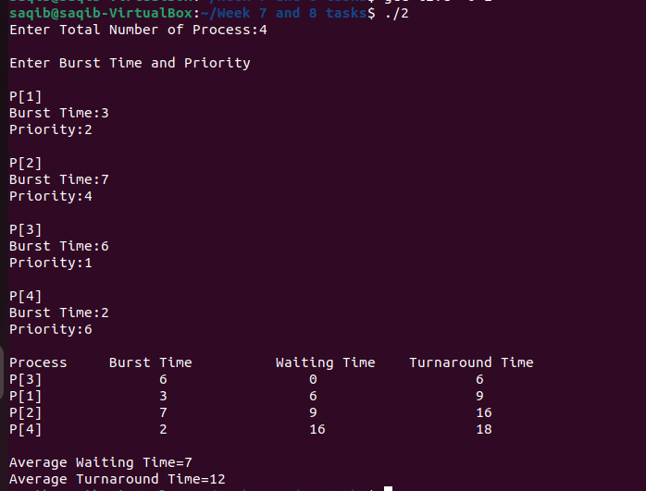

**Task 3: Shortest Job First:**

#include<stdio.h>

void main()

{

int bt[20],p[20],wt[20],tat[20],i,j,n,total=0,pos,temp;

float avg_wt,avg_tat;

printf("Enter number of process:");

scanf("%d",&n);

printf("\nEnter Burst Time:\n");

for(i=0;i<n;i++)

{

printf("p%d:",i+1);

scanf("%d",&bt[i]);

p[i]=i+1; //contains process number

}

//sorting burst time in ascending order using selection sort

for(i=0;i<n;i++)

{

pos=i;

for(j=i+1;j<n;j++)

{

if(bt[j]<bt[pos])

pos=j;

}

temp=bt[i];

bt[i]=bt[pos];

bt[pos]=temp;

temp=p[i];

p[i]=p[pos];

p[pos]=temp;

}

wt[0]=0; //waiting time for first process will be zero

//calculate waiting time

for(i=1;i<n;i++)

{

wt[i]=0;

for(j=0;j<i;j++)

wt[i]+=bt[j];

total+=wt[i];

}

avg_wt=(float)total/n; //average waiting time

total=0;

printf("\nProcess\t Burst Time \tWaiting Time\tTurnaround Time");

for(i=0;i<n;i++)

{

tat[i]=bt[i]+wt[i]; //calculate turnaround time

total+=tat[i];

printf("\np%d\t\t %d\t\t %d\t\t\t%d",p[i],bt[i],wt[i],tat[i]);

}

avg_tat=(float)total/n; //average turnaround time

printf("\n\nAverage Waiting Time=%f",avg_wt);

printf("\nAverage Turnaround Time=%f\n",avg_tat);

}

**Output :**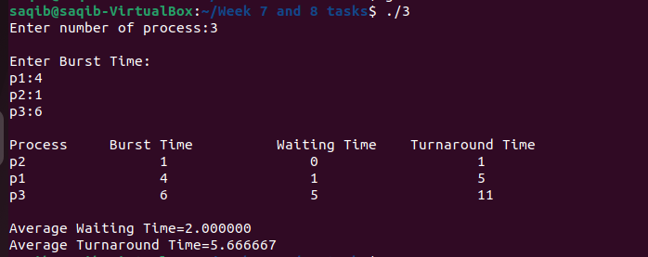

**Task 4: Round Robin:**

#include<stdio.h>

int main()

{

int count,j,n,time,remain,flag=0,time_quantum;

int wait_time=0,turnaround_time=0,at[10],bt[10],rt[10];

printf("Enter Total Process:\t ");

scanf("%d",&n);

remain=n;

for(count=0;count<n;count++)

{

printf("Enter Arrival Time and Burst Time for Process Process Number %d :",count+1);

scanf("%d",&at[count]);

scanf("%d",&bt[count]);

rt[count]=bt[count];

}

printf("Enter Time Quantum:\t");

scanf("%d",&time_quantum);

printf("\n\nProcess\t|Turnaround Time|Waiting Time\n\n");

for(time=0,count=0;remain!=0;)

{

if(rt[count]<=time_quantum && rt[count]>0)

{

time+=rt[count];

rt[count]=0;

flag=1;

}

else if(rt[count]>0)

{

rt[count]-=time_quantum;

time+=time_quantum;

}

if(rt[count]==0 && flag==1)

{

remain--;

printf("P[%d]\t|\t%d\t|\t%d\n",count+1,time-at[count],time-at[count]-bt[count]);

wait_time+=time-at[count]-bt[count];

turnaround_time+=time-at[count];

flag=0;

}

if(count==n-1)

count=0;

else if(at[count+1]<=time)

count++;

else

count=0;

}

printf("\nAverage Waiting Time= %f\n",wait_time*1.0/n);

printf("Avg Turnaround Time = %f",turnaround_time*1.0/n);

return 0;

}

**Output:**

